**Energy efficient teaching-learning-based optimization for the discrete routing problem in wireless sensor networks**

Wireless sensor networks (WSNs) are composed of sensor nodes, having limited energy resources and low processing capability. Accordingly, major challenges are involved in WSNs Routing. Thus, in many use cases, routing is considered as an NP-hard optimization problem. Many routing protocols are based on metaheuristics, such as Ant Colony Optimization (ACO) and Particle Swarm Optimization (PSO). Despite the fact that metaheuristics have provided elegant solutions, they still suffer from complexity concerns and difficulty of parameter tuning. In this paper, we propose a new routing approach based on Teaching Learning Based Optimization (TLBO) which is a recent and robust method, consisting on two essential phases: Teacher and Learner. As TLBO was proposed for continuous optimization problems, this work presents the first use of TLBO for the discrete problem of WSN routing. The approach is well founded theoretically as well as detailed algorithmically. Experimental results show that our approach allows obtaining lower energy consumption which leads to a better WSN lifetime. Our method is also compared to some typical routing methods; PSO approach, advanced ACO approach, Improved Harmony based approach (IHSBEER) and Ad-hoc On-demand Distance Vector (AODV) routing protocol, to illustrate TLBO’s routing efficiency.

**INTRODUCTION :**

Wireless Sensor Networks (WSNs) are network systems formed by sensors able to communicate without using any specific network infrastructure. There are various categories of sensors, depending on the environmental situation (temperature, humidity, pressure, etc. . . ) . Thus, WSNs are used in many applications such as disaster relief, environmental control, precision agriculture, medicine and health care. Nonetheless, there are some intrinsic limitations for the sensors like low process capacity or power, and limited lifetime. Hence, new issues appeared in operations research and optimization field.

Particularly, many researchers have tended to focus on routing problems.

Routing in WSN differs from routing in traditional communication networks by the lack of infrastructure, unreliable links, and energy consumption. On the other hand, it’s qualified as an NP-hard optimization problem, which means the necessity of metaheuristics to deal with it. Metaheuristics are robust techniques that start with a set of initial solutions called initial population in the context of evolutionary algorithms. Then step by step explores a sequence of solutions to reach the near-optimal solution. Recently, researchers have addressed these challenges by adopting optimization strategies.

There is a diverse range of metaheuristic algorithms used to optimize routing in wireless sensor networks including the Genetic Algorithm (GA) used to create energy efficient clusters for routing in wireless sensor networks. The Particle Swarm Optimization (PSO) [11–13] which is a simple, effective and computationally efficient optimization algorithm, investigated to address WSN issues such as optimal deployment, node localization, clustering, data aggregation, and routing. The Artificial Bee Colony (ABC), proposed in is an energy-efficient cluster based ABC procedure, for selecting the optimal cluster heads in order to reduce the consuming energy. Harmony Search (HS) used by Zeng, B. and Dong, Y. in to propose an Improved Harmony Search Based Energy Efficient Routing Algorithm (IHSBEER) for WSNs. And Ant Colony Optimization (ACO), etc

The choice of the right optimization algorithm can be crucially important in finding the best solutions for a given optimization scenario. In fact, the ACO metaheuristic has been successfully applied to solve routing problems in WSN. Some examples of ant-based applications are: Sensor-driven Cost-aware Ant Routing (SC), the Flooded Forward Ant Routing (FF) algorithm, the Flooded Piggy-backed Ant Routing (FP) algorithm, the Adaptive ant-based Dynamic Routing (ADR), the Adaptive Routing (AR) Improved Adaptive Routing (IAR) algorithm, and E&D ANtraTS. In addition, the authors in proposed Improved Ant Colony Optimization Routing protocol named IACOR, which was shown to be competitive with state-of-the-art approaches.

All the evolutionary and swarm intelligence based algorithms require controlling parameters, which affect the performance of the algorithm. Considering this fact, a new metaheuristic have been developed recently does not require any algorithm parameters to be tuned. Thus, making its implementation simpler and easier. This metaheuristic is known as Teaching-Learning-Based Optimization (TLBO). TLBO algorithm is based on the teacher’s influence on learners output in a class. This new method is originally designed for continuous optimization problems. Since its appearance, TLBO has been used successfully for many multi-objective problems and in different sectors [30, 31]. In this work, we use TLBO for routing in WSN, which is a discrete optimization problem. For this fact, we have proposed a redefinition of the TLBO’s equations basically by using the Edge Recombination Operator (ERO). All the evolutionary and swarm intelligence based algorithms require controlling parameters, which affect the performance of the algorithm. Considering this fact, a new metaheuristic have been developed recently does not require any algorithm parameters to be tuned. Thus, making its implementation simpler and easier. This metaheuristic is known as Teaching-Learning-Based Optimization (TLBO). TLBO algorithm is based on the teacher’s influence on learners output in a class. This new method is originally designed for continuous optimization problems. Since its appearance, TLBO has been used successfully for many multi-objective problems and in different sectors. In this work, we use TLBO for routing in WSN, which is a discrete optimization problem. For this fact, we have proposed a redefinition of the TLBO’s equations basically by using the Edge Recombination Operator (ERO).

This paper presents a new communication protocol for WSN based on TLBO, namely TLBOR. The proposed protocol uses packets request through the WSN looking for paths between the sensor nodes and sink. Then, teaching and learning phases are applied to find the path that at the same time short in length and energy efficient, contributing in that way to maximize the lifetime of the WSN. After some iterations, the TLBO protocol is able to build a routing path with optimized energy

Our TLBO-based model provides a good performance in terms of energy consumption, data delivery and reliability. To demonstrate that fact, many comparisons to other protocols such as IACOR, PSOR based routing, AODV and IHSBEER have been performed using MATLAB and C++. Basically, the comparisons environment is varied by changing the number of nodes, coverage areas, number of packets sent and other intrinsic parameters related to the position of the source node and the random deployment. The main objective of the simulations is to confirm the credibility of our routing protocol TLBOR.

The main contributions of this work are the foundation of a new approach for the discrete routing problem in WSNs using the TLBO metaheuristic that was proposed for continuous optimization problems, the integration of the ERO in the operation of this new routing approach and the comparisons with well known routing protocols in literature such as IACOR, PSOR, AODV and IHSBEER.

The remainder of this paper is as follows. Section 2 presents the routing in WSN. Section 3 introduces TeachingLearning-Based Optimization (TLBO). Section 4 describes TLBO adaptation to routing problem in WSN. Section 5 shows the performance evaluation of our algorithm. Finally, Section 6 concludes our work.

**EXITING SYSTEM :**

**Routing problem in wireless sensor networks :**

Forwarding data from source to destination in wireless sensor networks differs from that in classical networks in various ways. There is no infrastructure, wireless links are unreliable, sensor nodes may fail, and routing protocols have to meet strict energy saving requirements. Many routing algorithms developed for wireless sensor networks depend on the mobility of sensors or sinks, application field, and network topology. Overall, routing techniques are categorized according to the network structure or the protocol operation (routing criteria).

As shown in Fig. 1, networks structure gathers three different kinds of routing protocols: flat, hierarchical and location based routing. While negotiation, multipath, query and coherent based belong to protocol operation category. Recently, many works in WSNs focus on intelligent optimization using nature inspired metaheuristics systems. Many routing protocols are based on metaheuristics, the ones considered in this work for comparisons are:

• IACOR, the proposed routing protocol for a flat network. Using stable sensors and sink, the object is to locate the ideal way, with negligible vitality utilization and solid connections. When an event occurs, source node parts information to N parts, every part is transmitted to the base station by an insect. Ants choose the next hop by using probabilistic choice tenets, and so on until sink. This approach gives great results, comparing to routing protocol EEABR (Energy-Efficient Ant-Based Routing) and original ACO approach

• PSOR, the PSO routing protocol which is a population based protocol. It required an initial population (a number of paths from the source node to the sink) and redefined PSO equations to present an adequate adaptation for the discrete routing problem, then found the best path from the source to the destination. PSOR results are better than IACOR in terms of energy consumption and WSNs lifetime as illustrating the comparisons made using the same settings and experimental conditions.

• IHSBEER, is an Improved Harmony Search Based Energy Efficient Routing Algorithm for WSNs, which is based on harmony search (HS) algorithm with several key improvements to address the WSNs routing problem. Such improvements include the encoding of harmony memory, the improvisation of a new harmony and an effective local search strategy is proposed to enhance the exploitation ability, so as to improve the convergence speed and the accuracy of the IHSBEER routing algorithm.

To add more credibility and show the efficiency of the new routing approach proposed in this paper we compare it also with the Ad-hoc On-demand Distance Vector (AODV) routing protocol:

• The AODV is a reactive routing protocol, where the routes are determined just when required. Figure 2 shows the message exchanges of the AODV protocol.

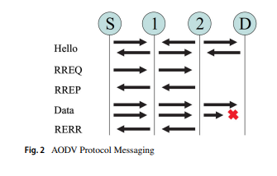

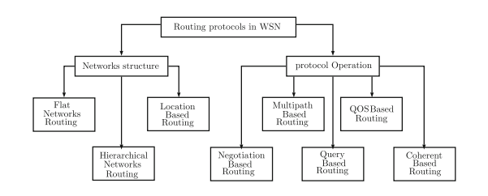

AODV-node informs its neighbors about its own particular presence by continually sending ”hello messages”. Thus, every node knows the states of its neighbors. To find a route to another node AODV sends a request (RREQ) to its neighbors. A RREQ contains the source node address and the last sequence number received. The receiving node verifies if a route exists and if the sequence-number is higher than the route found then, a route reply (RREP) is sent to the requesting. On the other hand, if the route does not exist, the receiving node sends a RREQ itself to try to find a route for the requesting node. If an error is detected, a route error (RERR) is sent to the source of data.

**PROPOSED SYSTEM :**

**Teaching-learning-based optimization :**

Teaching-Learning-Based Optimization algorithm (TLBO) is a novel optimization method proposed by Rao et al. This approach has been inspired by the teacher’s influence and learners interaction. It outperforms some of the well-known metaheuristics regarding constrained benchmark functions, constrained mechanical design, and continuous nonlinear numerical optimization problems. TLBO has been applied to various problems such as the QoS multicast routing problem and optimal reactive power dispatch problem [35]. It could be split into two basic parts: Teacher phase and Learner phase. Figure 3 describes the TLBO process.

**Teacher phase :**

Like many other nature-inspired algorithms, TLBO uses a population of solutions to proceed to the global solution. An initial population is a group of learners and the studied matters are design variables. Evaluated the entire population using “fitness” the best solution is considered as a teacher. In this phase, teacher influence is presented by shifting the mean of learners to its level of knowledge. Then get

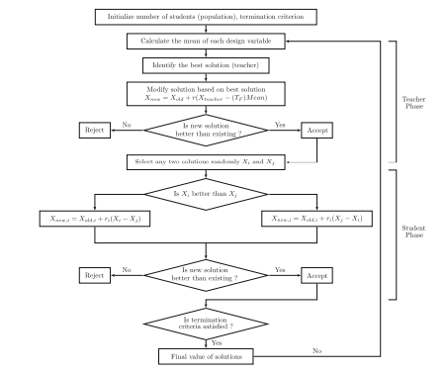

**The proposed approach based on TLBO :**

WSNs are known by the strict energy constraint and the limited energy replenishment capabilities. Thus, it is important to optimize the energy consumption for routing, so as to prolong the n

etwork lifetime as far as possible. In this section we propose a new routing protocol for WSNs, Teaching-learning-based optimization based routing (TLBOR). This new protocol is not centralized, which means that the algorithm should operate in each node. Its process begins by the initialization of the population of paths, then finding the optimum path using TLBO

algorithm, then sending data through it. Herein, the proposed methodology which adapts TLBO to WSN routing is detailed.

**Initial population** **and data division** :

The source node sends a broadcast message to their neighbors, which is a packet request that asks for an available route to the final destination, in order to collect information related to some paths that lead to the sink (see Fig. 4). Once the request packets are received, nodes check their routing table. If the route exists, source node receives directly this information. Otherwise, the receiver nodes request their neighbors, and so on.

The source node initializes the population, according to the number of paths toward the sink. The population of paths is denoted as P = {p1,...,pi,...,pm}, where every path pi is formed as pi = {ns,...,nk,...,nsink}

The initialization of the population is a task accomplished by a set of nodes in the WSN. For example (See Fig. 4) a source node S detecting an event sends a request to its neighbors, node 1, node 8, node 2 and node r. A neighbor r checks its routing table, in case a route toward the sink was stored, r informs the source node S. If not, the node r asks similarly its neighbors about path leading to the sink, r’s neighbors behave in the same way as the node r and so on. After a waiting time W T , all response packets are received by the source node S, which collects the information and generates a random initial population by a random number of paths.

The Waiting Time W T was defined according to the WSNs used, the number of nodes deployed and the simulation environment. After several simulations, we have affected the appropriate value to the W T , which change with the WSNs. The W T is used as the source node can not wait an infinity time for replies and the population.

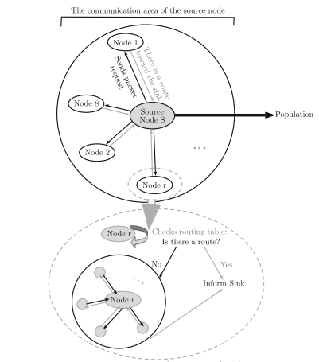

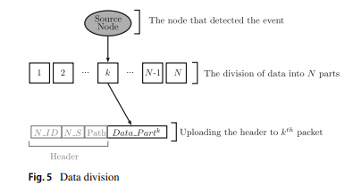

size should be a reasonable number regarding the limited capacities of the nodes in memories, processing and energy. Figure 4 shows a summary of how source node s requests its neighbor nodes and how a node r reacts after receiving this packets, it informs sink that a route exists or search a route by asking neighbors.

After the population initialization, the source node splits a raw data into N pieces in order to manage bandwidths. Raw data contain information such as event identification, time and data about the detected event. Before the transfer, each piece is associated with the routing parameters. These parameters are next node identification N ID, the sequence number N S and the path toward the sink Path as shown in Fig. 5

When the transmission is accomplished, the sink combines received parts to form the raw data.

**Implementation of TLBO :**

We implement TLBO for routing problems, following the five steps below:

Step 1 :

Initialization of the optimization parameters considered for routing problems and definition of the objective function

**Population size** (P n) depends on the number of nodes in the network and the waiting time. The source node waits a time TTL (Time To Live) for requests coming from the neighbors in order to form a number of paths (from the source node to the sink), this number is considered as the population size.

**Termination criterion** If the same path is revisited for many times during a number of iterations, this path is considered as the found solution then, the main loop is left. According to the objective function evaluation, this solution will provide good results in terms of the energy consumption and the WSN lifetime.

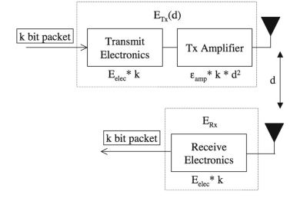

**Number of design variables :** In routing problems, the design variables are discrete, it corresponds to the number of possible nodes in a given path.

**Step 2 :**

The population is expressed as:

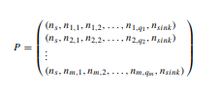’

Where the sizes of the paths are not necessarily the same. We denote qi the length of the path having the index i. The respective objective values are :



**Step 3: (teacher phase)**

In this phase, we should calculate the mean of each column in the population, but that can not be expressed analytically in routing (the population P does not contain any columns but several paths). Therefore, we must redefine some basic mathematical objects and operations in order to start using TLBO’s equation. We propose to use the Edge Recombination Operator (ERO) to tackle the discrete spaces. ERO has been developed to construct an offspring that inherits as much information as possible from the parent structures [32].

In the Fig. 7, we present an example of a WSN composed by 80 nodes, a source node S detects a event and for example we suppose that the initial population is: 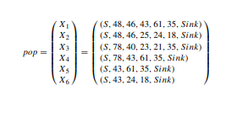

The mean of the population pop is a path XMean, it’s the result of ERO (see Algorithm 1) between all paths in the population.

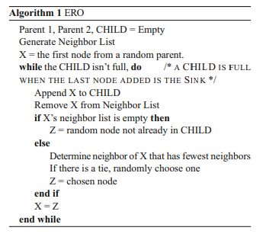

The mean of the population pop is a path XMean, it’s the result of ERO (see Algorithm 1) between all paths in the population.

**Edge recombination operator example** Given the following two parent solutions:



We generate the following neighbors list:

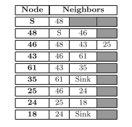

First, we randomly select the first node of a parent.



Next, after crossing S out from all neighbor lists, we see that 48 is the only neighbor in the list of S. So,



Next, after crossing 48 out from all neighbor lists, 46 is the only neighbor in the list of 48. So,



Next, after crossing 46 out from all neighbor lists, 43 and 25 both have only one neighbor, so we randomly choose between the two:



Next, after crossing 43 out from all neighbor lists, we see that 61 is the only neighbor in the list of 43. So,



Next, after crossing 61 out from all neighbor lists, the neighbor of 61 is 35:



Next, after crossing 35 out from all neighbor lists, 35 has only one neighbor and it has no neighbors left, its Sink:



In this work, using the crossover techniques ERO, we consider some settings related to the WSNs. Such as the source node is obligatory the first node in a child. When the Sink is in the list of neighbors, we choose it and we stop the process. After performing the ERO operator between paths in the population pop, the mean is XMean = (S, 78, 40, 23, 21, 35, Sink)

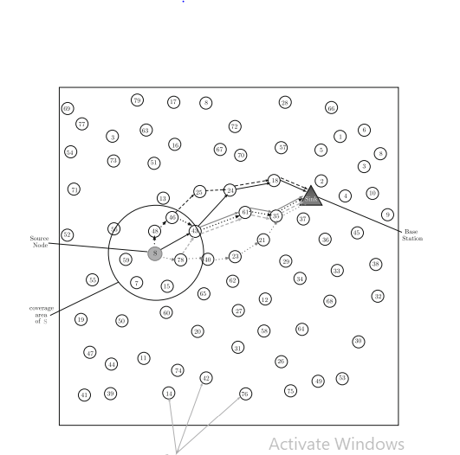

**Case 1** :

In this first case we have used a fixed energy level for all nodes in all scenarios however, we changed the number of packets sent. For every routing protocol used we simulated the transmission of 600 and 1000 packets in the 10 scenarios (the number of nodes in these scenarios varied from 10 to 100, with increments of 10). Figures 8 and 9 show the average residual energy of the nodes and the node lifetime: the metric used to evaluate the performance of the protocols. The average CPU time in seconds (CPU(s)) is given only for information. This measure depends on the number of nodes in the WSN, simulation area, the random deployment and the source node’s position against the Sink. The node lifetime Lt is calculated knowing the initial energy of the battery E0 and the power P, consumed by the device following the formula (9) proposed by authors in [37].



Lt = E0 PAfter 600 packets are received by the sink node for different WSNs having a various number of nodes. From the Fig. 8 we can find that TLBOR gives the best results in the vast majority of the scenarios. Higher residual energy means less energy cost. It indicates that TLBOR can save much more energy than IACOR, PSOR, IHSBEER and AODV do, for transmitting the same size packet to the sink node.

Figure 9a shows the residual energy after the reception of 1000 packets, as we can see the results obtained by TLBOR are better than those obtained by PSOR, IACOR, IHSBEER and AODV. The residual energy directly affects the network lifetime, WSN with maximum residual energy is greater, and the network lifetime will get longer Fig. 9b. From results, it is evident that TLBOR will perform better in prolonging the network lifetime than the other routing protocols do in all scenarios as shown in Fig. 9.

**Case 2 :**

Herein we compare our routing protocol TLBOR behavior with IACOR, PSOR, IHSBEER and AODV in two WSNs composed by 100 and 200 nodes. In the same experimentation’s conditions, we simulate the transmission of a varied number of packet from 64 to 640 packets. It can be seen from Fig. 10 that overall by increasing the number of packets the TLBOR protocol gives the best result obtained.

To be certain that our approach based TLBO (TLBOR) is well performing for large-scale problems as well, we performed additional experiments on a WSN with 200 nodes. The TLBOR presented in the Fig. 11 (blue circles) surpasses clearly all routing protocols. From the obtained results we can deduct that our approach based on TLBO is better in saving the WSN energy as well as extending the network lifetime.

From the Fig. 11 it is clear that our routing protocol based on TLBO, optimize energy in WSNs better than PSOR, IACOR, IHSBEER and AODV based protocol.

**Case 3 :**

By performing many simulations, we show that the proposed protocol is better than the routing protocols mentioned above. Our improved approach is the highest by examining the average residual energy of 10 runs. Thus, the power consumption is reduced, and the WSN lifetime is maximized especially when densities are high. In order to verify the efficiency of our proposal we have applied the A-test (Vargha-Delaney A measure [38]).

The Vargha-Delaney A measure tells us how often, on average, one technique outperforms the other. The A-test returns a value between 0 and 1. When the A-measure is exactly 0.5, there is no difference between the two techniques. When the A-measure is less than 0.5 the first technique has the worse performance. Otherwise, the second technique is the worst performing one. The closer to 0.5, the smaller the difference between the techniques; the farther from 0.5, the larger the difference.

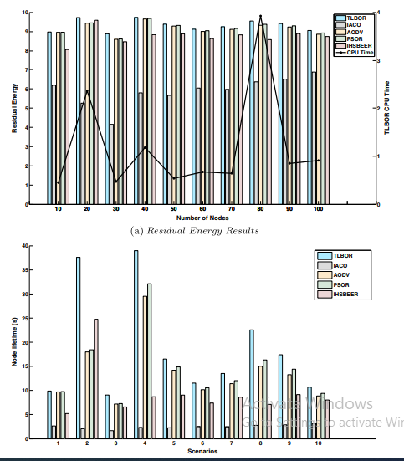

In our case, the samples are composed of the residual energy from each algorithm using 10 independent runs of each algorithm. The A-test value represents the probability that a randomly selected observation from one sample is better than a randomly selected observation from the other sample. The A-test return 1.000, this means that the proposed routing protocol TLBOR exceeds the other studied protocols in all presented scenarios.

Table 2 shows the A-test of a pairwise comparison between the other state-of-the-art algorithms for each scenario. Although the Table 2 shows the same results, the objective remains to demonstrate the superiority of our proposal in many scenarios, this is why we have applied the A-test (Vargha-Delaney A measure [38]), which illustrates how often, our technique outperforms the other one.

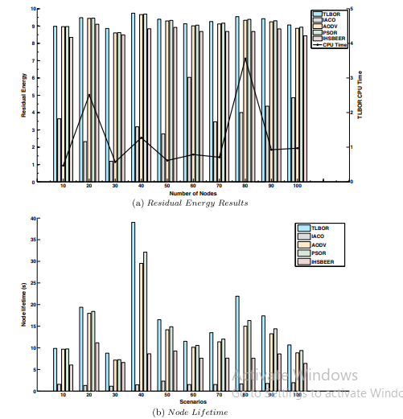

From the results of the experiments, we can find that the TLBOR protocol always has presented the best results in all metrics. We concluded that TLBOR can perform better in the WSN energy consumption and extend the WSN lifetime than IACOR, PSOR, IHSBEER and AODV do.

**HARDWARE & SOFTWARE REQUIREMENTS:**

**HARD REQUIRMENTS :**

* System    :   Pentium IV 2.4 GHz.
* Hard Disk  :   40 GB.
* Floppy Drive :   1.44 Mb.
* Monitor :   15 VGA Colour.
* Mouse    :   Logitech.
* Ram    :   512 MB.

**SOFTWARE REQUIRMENTS :**

* Operating system   : Windows 7 Professional.
* Coding Language  : python

# 4.SYSTEM DESIGN

## 4.1 UML DIAGRAMS :

UML stands for Unified Modeling Language. UML is a standardized general-purpose modeling language in the field of object-oriented software engineering. The standard is managed, and was created by, the Object Management Group.

The goal is for UML to become a common language for creating models of object oriented computer software. In its current form UML is comprised of two major components: a Meta-model and a notation. In the future, some form of method or process may also be added to; or associated with, UML.

The Unified Modeling Language is a standard language for specifying, Visualization, Constructing and documenting the artifacts of software system, as well as for business modeling and other non-software systems.

The UML represents a collection of best engineering practices that have proven successful in the modeling of large and complex systems.

The UML is a very important part of developing objects oriented software and the software development process. The UML uses mostly graphical notations to express the design of software projects.

## GOALS:

The Primary goals in the design of the UML are as follows:

1. Provide users a ready-to-use, expressive visual modeling Language so that they can develop and exchange meaningful models.
2. Provide extendibility and specialization mechanisms to extend the core concepts.
3. Be independent of particular programming languages and development process.
4. Provide a formal basis for understanding the modeling language.
5. Encourage the growth of OO tools market.
6. Support higher level development concepts such as collaborations, frameworks, patterns and components.
7. Integrate best practices.

USE CASE DIAGRAM:

A use case diagram in the Unified Modeling Language (UML) is a type of behavioral diagram defined by and created from a Use-case analysis. Its purpose is to present a graphical overview of the functionality provided by a system in terms of actors, their goals (represented as use cases), and any dependencies between those use cases. The main purpose of a use case diagram is to show what system functions are performed for which actor. Roles of the actors in the system can be depicted.



# CLASS DIAGRAM:

In software engineering, a class diagram in the Unified Modeling Language (UML) is a type of static structure diagram that describes the structure of a system by showing the system's classes, their attributes, operations (or methods), and the relationships among the classes. It explains which class contains information.



SEQUENCE DIAGRAM:

A sequence diagram in Unified Modeling Language (UML) is a kind of interaction diagram that shows how processes operate with one another and in what order. It is a construct of a Message Sequence Chart. Sequence diagrams are sometimes called event diagrams, event scenarios, and timing diagrams.



COLLABRATION DIAGRAM:

Activity diagrams are graphical representations of workflows of stepwise activities and actions with support for choice, iteration and concurrency. In the Unified Modeling Language, activity diagrams can be used to describe the business and operational step-by-step workflows of components in a system. An activity diagram shows the overall flow of control.



## IMPLEMENTATION:

## MODULES:

To implement this project we have designed following modules

1.Generate Network : button to generate some dummy sensors like below screens.

2.Initialize Network : button to find parent nodes which are closer to base station or to find node which accept data from sensor and send to base station.

3.Run Teacher Learner Based Routing : button to send message like below screen.

4.Energy Consumption : graph button to get below graph.

**CONCLUSION :**

Routing in WSN has introduced many challenges compared to traditional data routing in wired networks. This paper presents a new routing protocol using a novel optimization method based on the philosophy of the teaching-learning process combined with the edge recombination operator. That TLBO approach ensures a robust optimization of the energy consumption, thus increases network lifetime as validated by simulation results. By performing experimentation in the same simulation conditions, TLBOR protocol is compared to some routing protocol in WSNs such as: ACO, PSO and IHSBEER approaches and AODV protocol. Then overall the results show that our TLBOR protocol is better in terms of energy consumption and network lifetime. As a future work, it is planned to improve our routing approach by incorporating other quality of service (QoS) metrics and performing the experimentation in real WSN. Additionally, the improved approach will be applied to mobile nodes and networks with multiple sinks.

**REFERENCES :**

Potdar V, Sharif A, Chang E (2009) Wireless sensor networks: A survey. In: International Conference on Advanced Information Networking and Applications Workshops. WAINA’09., IEEE, pp 636–641

2. Akyildiz IF, Su W, Sankarasubramaniam Y, Cayirci E (2002) Wireless sensor networks: a survey. Comput Netw 38(4):393–422

3. Xu N (2002) A survey of sensor network applications. IEEE Commun Mag 40:102–114

4. Anisi MH, Abdul-Salaam G, Idris MYI, Wahab AWA, Ahmedy I (2017) Energy harvesting and battery power based routing in wireless sensor networks. Wirel Netw 23(1):249–266

5. Masri WW (2009) QoS requirements mapping in TDMA-based Wireless Sensor Networks. PhD thesis. Toulouse University IIIPaul Sabatier

6. Gogu A, Nace D, Dilo A, Mertnia N (2011) Optimization problems in wireless sensor networks. In: International Conference on Complex, Intelligent and Software Intensive Systems (CISIS). IEEE, pp 302–309

7. Ali MKM, Kamoun F (1993) Neural networks for shortest path computation and routing in computer networks. IEEE Trans Neural Netw 4:941–954

8. Al-Karaki JN, Kamal AE (2004) Routing techniques in wireless sensor networks: a survey. Wirel Commun 11(6):6–28

9. Blum C, Roli A (2003) Metaheuristics in combinatorial optimization: Overview and conceptual comparison. ACM Comput Surv 35:268–308

10. Hussain S, Matin AW, Islam O (2007) Genetic algorithm for energy efficient clusters in wireless sensor networks. In: ITNG, pp 147–154

11. Kulkarni RV, Venayagamoorthy GK (2011) Particle swarm optimization in wireless-sensor networks: A brief survey. IEEE Trans Syst Man Cybern Part C Appl Rev 41(2):262–267

12. El Ghazi A, Ahiod B (2016) Particle swarm optimization compared to ant colony optimization for routing in wireless sensor networks. In: Proceedings of the Mediterranean Conference on Information & Communication Technologies. Springer, pp 221–227

13. Zhao C, Wu C, Wang X, Ling BWK, Teo KL, Lee JM, Jung KH (2017) Maximizing lifetime of a wireless sensor network via joint optimizing sink placement and sensor-to-sink routing. Appl Math Model 49:319–337

14. Saleh S, Ahmed M, Ali BM, Rasid MFA, Ismail A (2014) A survey on energy awareness mechanisms in routing protocols for wireless sensor networks using optimization methods. Trans Emerg Telecommun Technol 25(12):1184–1207

15. Mann PS, Singh S (2016) Artificial bee colony metaheuristic for energy-efficient clustering and routing in wireless sensor networks. Soft Comput 21:1–14

16. Zeng B, Dong Y (2016) An improved harmony search based energy-efficient routing algorithm for wireless sensor networks. Appl Soft Comput 41:135–147

17. Fathima K, Sindhanaiselvan K (2013) Ant colony optimization based routing in wireless sensor networks. Inter J Advan Netw Appl 4(4):1686–1689

18. Okdem S, Karaboga D (2009) Routing in wireless sensor networks using an ant colony optimization (aco) router chip. Sensors 9:909–921

19. Zhang Y, Kuhn LD, Fromherz MP (2004) Improvements on ant routing for sensor networks. In: Ant Colony Optimization and Swarm Intelligence. Springer, pp 154–165

20. Lu Y, Zhao G, Su F (2004) Adaptive ant-based dynamic routing algorithm. In: Intelligent Control and Automation, 2004. WCICA 2004. Fifth World Congress on. Volume 3., IEEE, pp 2694–2697

21. GhasemAghaei R, Rahman MA, Gueaieb W, El Saddik A (2007) Ant colony-based reinforcement learning algorithm for routing in wireless sensor networks. In: Instrumentation and Measurement Technology Conference Proceedings, IEEE, pp 1–6

22. Wen YF, Chen YQ, Pan M (2008) Adaptive ant-based routing in wireless sensor networks using energy* delay metrics. J Zhejiang Univ Sci A 9(4):531–538

23. El Ghazi A, Ahiod B, Ouaarab A (2014) Improved ant colony optimization routing protocol for wireless sensor networks. In: Networked Systems. Springer, pp 246–256

24. Rao RV, Savsani VJ, Vakharia D (2011) Teaching–learning-based optimization: a novel method for constrained mechanical design optimization problems. Comput Aided Des 43(3):303–315

25. Rao RV, Savsani VJ, Vakharia D (2012) Teaching–learning-based optimization: an optimization method for continuous non-linear large scale problems. Inf Sci 183(1):1–15

26. Crepin ˙ sek M, Liu SH, Mernik L (2012) A note on teaching– ˙ learning-based optimization algorithm. Inf Sci 212:79–93

27. Waghmare G (2013) Comments on ?a note on teaching–learningbased optimization algorithm Inf Sci 229:159–169

28. Raja BD, Jhala R, Patel V (2016) Multi-objective optimization of a rotary regenerator using tutorial training and self-learning inspired teaching-learning based optimization algorithm (ts-tlbo). Appl Therm Eng 93:456–467

29. Rao RV, Rai DP, Balic J (2016) Multi-objective optimization of machining and micro-machining processes using non-dominated sorting teaching–learning-based optimization algorithm. Journal of Intelligent Manufacturing 1–23

30. Xu Y, Wang L, Wang SY, Liu M (2015) An effective teaching– learning-based optimization algorithm for the flexible job-shop scheduling problem with fuzzy processing time. Neurocomputing 148:260–268

31. Sahu BK, Pati S, Mohanty PK, Panda S (2015) Teaching– learning based optimization algorithm based fuzzy-pid controller for automatic generation control of multi-area power system. Appl Soft Comput 27:240–249

32. Whitley LD, Starkweather T, Fuquay D (1989) Scheduling problems and traveling salesmen: The genetic edge recombination operator. In: ICGA. Volume 89, pp 133–40

33. Perkins C, Belding-Royer E, Das S (2003) Ad hoc on-demand distance vector (aodv) routing. Technical report

34. Naik A, Parvathi K, Satapathy SC, Nayak R, Panda B (2013) Qos multicast routing using teaching learning based optimization. In: Proceedings of International Conference on Advances in Computing, Springer, pp 49–55

35. Ghasemi M, Taghizadeh M, Ghavidel S, Aghaei J, Abbasian A (2015) Solving optimal reactive power dispatch problem using a novel teaching–learning-based optimization algorithm. Eng Appl Artif Intell 39:100–108

36. Heinzelman WR, Chandrakasan A, Balakrishnan H (2000) Energy-efficient communication protocol for wireless microsensor networks. In: Proceedings of the 33rd Annual Hawaii International Conference on System Sciences, IEEE, pp 1–10

37. Sosedka J, Shostko I (2014) Calculation method for power consumption and lifetime of nodes in WSN Problems of Infocommunications Science and Technology. In: 2014 1st International Scientific-Practical Conference, IEEE, pp 116– 117

38. Vargha A, Delaney HD (2000) A critique and improvement of the CL common language effect size statistics of McGraw and Wong. In: Journal of Educational and Behavioral Statistics. Sage Publications. Volume 25, pp 101–132